**LINUX FOR PROGRAMMER**

Linux is an open-source Operating System and a flavor of UNIX. An Operating System is software that communicates between Hardware and Software of Computer. Operating System of Unix/Linux works on Kernel. UNIX is multi-user as well as multitasking because several people can use a Unix Computer at the same time and user can run multiple programs at the same time. Linux is released under General Public License (GPL) that means people can read the source code and can also modify and share. Linux is the basic requirements of the every IT initiatives like cloud computing, security and containers. Linux has grown as the people started understanding of the importance and working system of Linux. It is very easy to use as it comes in GUI form that makes easy to use for everyone. Linux has many distributions of Linux like Ubuntu, fedora, kubuntu, Arch Linux, Mageia and many more. Different distributions for different people according to requirements.

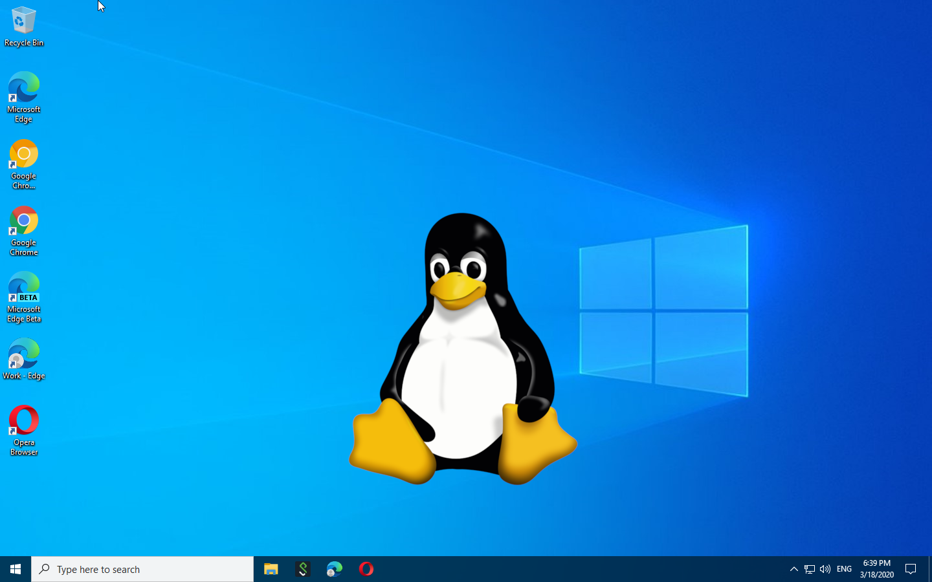

**WHY LINUX OVER WINDOWS**

1. Open Source: -

Linux is an open source and also, we can look and analyze the source code of Linux.

2. Secure:-

Security is an important factor for a person. Linux is not as vulnerable as Windows and a lot more secure. You don't need any Antivirus in Linux whereas you have to buy Antivirus Program every year to be secured from hackers.

3. Perfect for programmers:-

Linux offer large range of applications for programming purposes. Linux also offer predefined libraries for developers. Linux has ability of bash scripting which is one of the most important reasons programmer should prefer using Linux OS. It also supports SSH which helps manage the server quickly.

4. Software updates:-

Linux is updated frequently, and much faster. Whereas, In Windows Microsoft update only when receives major issues and need to be fixed.

5. Variety of Distributions:-

Windows doesn't have any flavor, whereas, Linux has large variety of distributions. You can use different Linux according to needs or requirements.

E.g.:- There is Linux distribution for hacker, for programmers, etc.

6. Reliability:-

You need to reboot every time you install or uninstall or update any software in Windows. Whereas, In Linux you don't need to reboot every time.

**STRUCTURE OF LINUX:-**

Linux operating system is structured in the same way of other operating system i.e.:-

* system software/user process/user utility/compilers
* system Libraries
* Kernel
* Kernel Modules

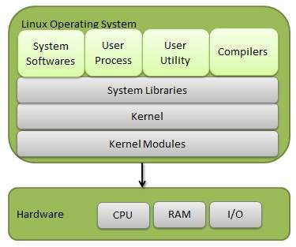

**system software/user process/user utility/compilers**

Software for everyone (users) written and published by GNU Project. This is the upper layer which is seen in GUI form by users.

**System Libraries -** Libraries are pre-compiled piece of code to communicate with the kernel. These libraries help in accessing kernel features which will be triggered to perform tasks. It makes easier for the programmer to build an application.

Some of the libraries in Linux are - libs, glibc, libcurl, libcrypt and many more.

1. libc is the standard C library

2. glibc is GNU version of standard C library

3. libcurl is multi-protocol file transfer library

4. libcrypt is the library used for encryption, hashing and encoding

**Kernel-** The heart of the Operating System which interacts with the hardware and lets the tasks perform like device management, memory management and process management.

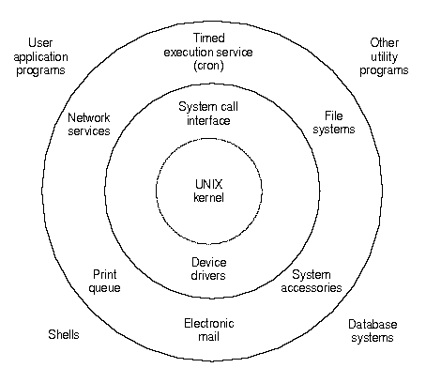

Interaction with kernel is done through Shell. Shell is a command line user interface. Shell translates the command from user into the language understood by kernel and vice-versa. Shell is also a scripting language used by Operating System to control the executions of the system using Shell Scripts.

**Hardware**

Physical equipment like keyboard, mouse and other physical devices connected with your system.

Once you enter the Unix/Linux Operating System, Open Terminal or press "CTRL+ALT+T" for terminal to appear and start working. On Terminal you will notice dollar ($) or hash (#) symbol on the left. This indicates the type of user you are.

Dollar Sign ($) indicates that you are a normal user and don't have administration permission. You are using this Operating System as a guest.

Hash Sign (#) indicates that you are the system administrator i.e. in root mode and you have all permissions in the system.

E.g.: If it's ($) and try to change the password, you won't be allowed to do so but if you switch to root mode i.e. (#) you will have permission to do so.

You can switch from guest to user by

$ su root

OR

$ sudo root

To switch to any user by

$ su <username> OR $ sudo <username>

You can run root commands from user by using "sudo" before command

e.g.

$ sudo command

You can check for the user you are in by

$ whoami

To list all the users in System by

$ users

To check the manual of "ls" command

$ man ls

**FILE SYSTEM OF LINUX**

File System is a tree like structure of directories. Data in Linux is organized in files and files in directories. Linux follow File system Hierarchy Standard (FHS). It explains the content and location of the files and directories. you can know about your file system FHS, by command "man hier" this will open the manual of hierarchy of file system.

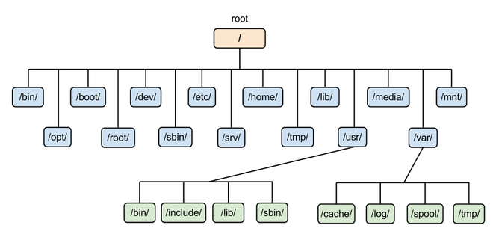

There are 3 basic types of files in Linux/UNIX OS:-

1. Directories - Directories are equivalent to the Folders in Mac OS or Windows. It stores both special and ordinary files.

2. Special Files - Some files which provide access to hardware like hard drives, modems, Ethernet and CD-ROM.

3. Ordinary Files - Files on the system that contains data, text or program instructions.

**DIRECTORIES OF LINUX**

Directories are the folders in Linux organized in tree structure. The tree has single root node shown by slash (/).

To create a new directory

$ mkdir mynewdir

To create a directory in another directory

$ mkdir /temp/aarju_dir/new_direct

To remove a directory

$ rmdir mynewdir

Renaming directory

$ mv old_dir new_dir

**PATHNAME**

To know the current path you are in

$pwd

There are 2 types of pathname in Linux Absolute and Relative.

Absolute - path begin with a slash (/)

Eg -

$ pwd

/etc/passwd

Relative - start with your current working directory name and never with slash (/)

Eg -

$ pwd

aarju_files/notes

To list all the files in directory

$ ls /usr/share

This will list all files in share directory in usr

**Commands for Linux File**

To list the files in current directory

$ ls

To list the files in current directory with their information like permissions.This will list the files with their permissions and many more details.

$ ls -l

$ ls -la

To create a new file

$ touch file_name

$ cat > file_name

To remove a file

$ rm file_name

To copy from one path to another

$ cp file1 path1 path2

To copy in same directory

$ cp existing_file_name new_file_name

To rename a file or directory

$ mv file_name new_name

To display the beginning of a file

$ head file.txt

To display last part of a file

$ tail file.txt

To display the content of the file

$ cat file.txt

To copy the content in another file

$ cat file1.txt > file2.txt

To concatenate contents of different files in one single file

$ cat file1.txt file2.txt file3.txt > new_file.txt

To append the content of a file

$ cat >> file_name.txt

To display the content with their line numbers

$ cat -n file_name.txt

To remove the empty lines form the file

$ cat -b file.txt

To display the end marker at the end of the file

$ cat > file.txt << end_marker_word

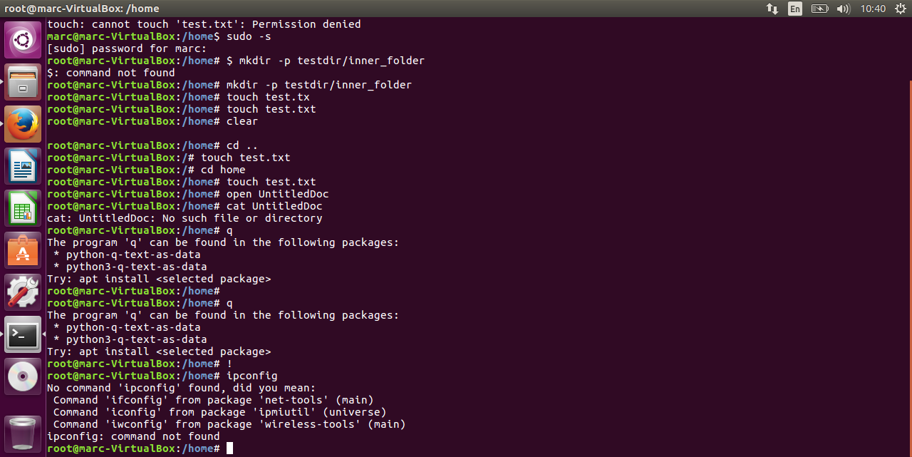

**PERMISSIONS OF THE FILES AND DIRECTORIES IN LINUX**

Each file in Linux has attribute and have permissions of owner,Group and other.

"ls -l" OR "ls -la" will list the file and their details including permissions each file in

$ ls -l

$ ls -la

drwxr-xr-x 2 root root 4096 Jul 3 01:57 doc-base

drwxr-xr-x 2 root root 4096 Jul 3 01:57 dpkg

-rwxr--r-- 1 root root 0 Aug 5 07:48 file_new.txt

"d" represent the directory and without d is the file. Here "drwxr-xr-x" and "-rw-r--r--" represent the permission of Owner, Group and Others in order:- read(r), write(w) and execute(x)

* first(1) represent the directory or file
* (2-4) i.e (rwx) in (-rwxrw-r--) and (rwx) in (drwxr-xr-x) represent the permission of file owner. Owner of the file have permission to read,write and execute.
* (5-7) i.e (rw-) in (-rwxrw-r--) represent the permission of the group to which this file belongs. Groups have permission only to read and write but not to execute.
* (8-10) i.e (r--) in (-rwxrw-r--) represent the permission for everyone. Everyone has the permission to read the file.

**Changing the file permissions**

Permission to a file is given by +/-/==

(+) is to add permission, (-) to remove permission and (==) to set the assigned permission

$ ls -l testfl

-rwxrw-r-- 1 aarju users 1024 Aug 2 00:10 testfl

Group have permission only to read and write this file but not to execute. Now to give permission to execute

$ chmod g+x textf1 OR $ chmod 774 textfl

-rwxrwxr-- 1 aarju users 1024 Aug 2 00:15 testfl

To remove the execute permission from owner

$ chmod o-x textf1 OR $ chmod 474 textfl

-rw-rwxr-- 1 aarju users 1024 Aug 2 00:20 testfl

Execute Permission is represented by number "1" and ref "--x"

Write Permission is represented by number "2" and ref "-w-"

Read permission is represented by number "4" and ref "--r"

To write and execute: 1+2 = 3 i.e "-wx"

To read and execute: 4+1 = 5 i.e "r-x"

To read and write: 4+2 = 6 i.e "rw-"

All permissions i.e to read,write and execute: 4+2+1 = 7 i.e "rwx"

